New to Pressure Mapping?
Before you begin, spend a moment thinking about and recording your current seating/sleeping conditions. These observations will help you and your care-team identify the positioning and strategies that are best for your risk factors and lifestyle.
- Describe the status of your skin on your buttocks and spine:

- Do you have a history of skin wounds/pressure injuries to these areas?

- Is your sensation of weight-bearing surfaces: Intact? Diminished? Absent? (circle one)
- If pressure mapping in bed, describe the mattress/support surface you sleep on:
Commercial Mattress (circle): Foam? Inner Spring? Memory Foam? Other:

- Medical Mattress or Overlay: Group 1 Group 2 Make/Model:

- Describe your sleep positions, including supports used:
back (supine)

stomach (prone)

right side

left side

- What is the make/model and size of your seat cushion?
- Are you pressure mapping your seat cushion in your wheelchair? Y/N
- What other equipment comes in contact with your skin?
Circle all that apply: commode; shower chair; sling; transfer device; car seat; other:

- What methods do you use to relieve pressure from your buttocks during the day?
Circle: trunk forward lean; sideways lean; push up
How often?
How long (in seconds/minutes)?

Or circle: tilt wheelchair; recline wheelchair; both tilt and recline
How often?

How long (in minutes)?

How far in degrees? (Upright is 90 degrees; flat is 180 degrees):

Consider using an angle finder tool or an app such as the Spirit Level Free by IntegraSoft.
- Circle your risk factors/activities:
 | Bump up/down steps | Sports | Travel | Smoking
 | Dehydration | Friction | Shear | Heat
 | Moisture | Past surgeries | Obesity | Infection
 | Muscle atrophy | Malnutrition | Vascular compromise–Hypoxia | Medications- Steroids
 | Diabetes Mellitis | Immunocompromised | History of stage 3 or 4 wounds which causes poor tensile strength and elasticity of tissue; | Collegen disorders
 | Undergarments with wrinkles or holding moisture
Remember: change position every 15 to 20 minutes for 2-3 minutes to help prevent skin injuries

Before you transfer onto the mat:
- Conduct a pre-test; let someone else sit on the mat to check that all the sensors are working.
- Do not use a transfer board. There is risk it will damage the mat.
- Be careful not to pull or tug on the mat as you transfer.
- Once seated, check that your clothing or sling (should be removed) is not bunched or wrinkled between you and the mat. Adjust seams if necessary. (When palpating, wearing a small plastic grocery bag over the hand makes it easy to slide between body and mat and is good for hygiene.)
- Avoid the mat hammocking. This is particularly a concern with air and contour cushions. The mat should be centered and smooth.

Now with the pressure mat in place, consider:
- Are you in a position that is typical for you? (Allow 2-3 minutes for your body, mat and cushion to settle and for the IPM image to stabilize. (5-7 minutes is needed for fluid and viscoelastic foam cushions.)
- Is the image symmetrical? Do both halves of the pattern look about the same? If not, consider: are your feet and arms equally supported? Are your hips/pelvis level with one another? Is your spine/trunk and pelvis centered on the mat?
Another factor is if you have a different amount of tissue on the left or right or if you've had flap or hip surgery. A wheelchair evaluation is needed if you are unable to assume or maintain a symmetrical posture with a level pelvis and spine.
- Is the image an even outline of thighs as well as buttocks? Ideally, your thighs should accept 40% of your body weight. The mat can help you determine if you need to shift more or less weight to your thighs or buttocks with footrests and armrest adjustment or cushion modifications.
- Does the image reveal hot spots? Often these occur around your sit bones (ischial tuberosity bones). This area should not accept more than 55% of your body weight on a cushion.
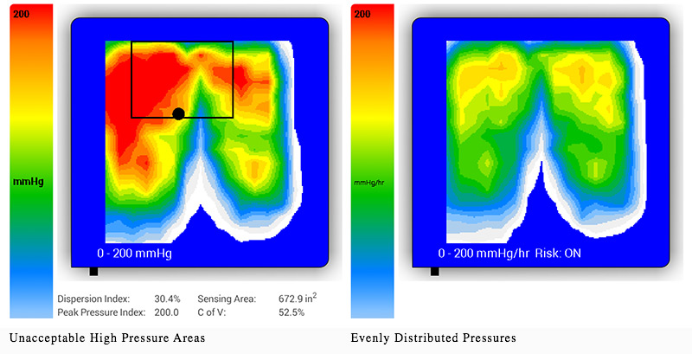
Your tailbone (coccyx and sacrum) usually only bears weight on a cushion if you are sitting with a posterior pelvic tilt (pelvis rolled back). However, coccyx and sacrum injuries are more frequent from sleep positions and sometimes from commode/shower positions or seat cushions with a back wall.
Try the following pressure relieving techniques (and keep in mind that it takes 2-3 minutes for blood to flow back into all the cells for the pressure relief to be effective):
- Lean your trunk forward (shoulders/elbows over the knees for the full benefit of lifting your ITs, sitting bones).
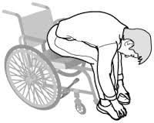
- Lean sideways (lifting right and then left hip off the cushion), and push up (lift buttocks straight up and off the cushion)
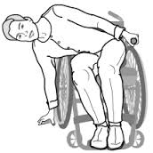
Or
- Tilt your wheelchair (up to 55 degrees for full benefit). Zero (0) is a level seat.
- Recline your wheelchair (120 degrees for full benefit. Straight upright is 90 degrees, full recline is 180 degrees). Look for shear: is skin pulled? Elevating legs may help to reduce shear.
- If both tilt and recline (up to 155 degrees for full benefit): start with 25-35 degrees tilt then 100- 120 degrees recline. When returning, start with reversing recline then un-tilt to come up. This reduces shear and keeps hips back.
- If you are comparing cushions with the pressure map:

- Remember to give 3-7 minutes for the cushion material, mat and your body to settle before reading the results of each cushion.
- Compare their thicknesses and adjust footrests and armrests as necessary to achieve foot and arm weight bearing equilibrium (see considerations 2 and 3 above).
- Remember that pressure mapping is only part of the story. A cushion must meet your positioning and postural needs as well as be comfortable!
- If adjusting air volume: remember to off-load the cushion to allow the air to equalize in the cushion. Then allow settle time before reading the results. The stiffness of the pressure mat may interfere with function of a Roho air style cushion and not give an accurate reading.
Record for EACH session/cushion (your digital file may include multiple numbered sessions):

- Your peak pressure: ____________________________
Pressure above 80-100 mmHg is a concern if combined with risk factors. With risk factors, your peak number should be lower in order to protect vulnerable tissue.
- Does the image show gradual pressure transitions? Circle Y/N.
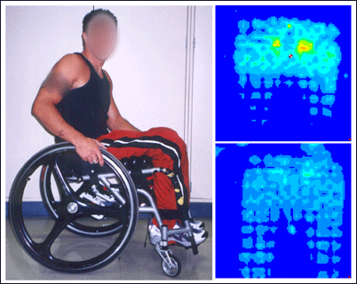 | The pressure maps to the left show pressure before and after adding a wedge (under the thighs) to the wheelchair user’s seating, improving distribution of pressure (the top image is without the wedge).
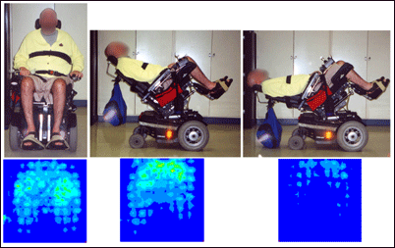 | The pressure maps to the left show the pressure changes that result for this person from tilting and reclining.
- Test pressure reducing techniques: lifting, leaning, tilting, recline.
Record your own observations of pressure reducing techniques (note that you can print images from the tablet with an installed printer):

Remember: damage from lack of blood flow takes approximately 6 hours. But damage to tissue and cell deformation can occur in a few minutes to an hour (due to pressure and shear occurring on the inside).

Are you at risk for a pressure injury? Consult with an occupational therapist or physical therapist skilled in wheelchair seating. See the listing for wheelchair clinics in your area that is included in this manual. Save this pressure mapping self-evaluation for future consultation and decision making!

For further assistance, contact BlueChip Medical (makers of this pressure mat):
Ron Resnick RResnick@bluechipmedical.com
Sarah Bandzak SBandzak@bluechipmedical.com

